I treat every row in activity file as a linked trip to get the linkedTrip.RData.

Step2_AugTable. R involves with "ChangeMode" trips and mainly delete ChangeMode trips in place file to get Linkedtrips. While there is only activity file and no place file in Portland_94 data. In activity file, there is no value that indicates "ChangeMode" in field ACT1 (What is your activity). And there is a field MODCHG indicating "Did you change mode?" in activity file.  Each row in activity file is treated as a linked trip.

Some key points about generating linked trip follows.

1. AGGACT (aggregated activity) and TPURP (main activity)

|  |  |  |
| --- | --- | --- |
| **AGGACT** | **2010 TPURP** | **1994 TPURP** |
| ChangeMode | 7 change of mode/transportation |  |
| EatOut/Meals | 17 eat meal outside of home | 11-Meals; |
| Escort | 8 dropped off passenger from car; 9picked up passenger from car | 22-Pick-Up/Drop-Off passengers |
| Home | 2all other at home activities |  |
| Other | 97other, specify | 90-Incidental trip; 91-Tag along trip |
| PersonalBus | 12service private vehicle  15household errands (bank, dry clean...); 16 personal business (visit government office,  attorney, accountant) | 16-Personal service; 17-Medical care  18-Professional Service; 19-Household or personal business; 20-Household maintenance; 21-Household obligations; 31-Visiting; |
| 18health care (doctor, dentist) |
| Recreation | 20 outdoor recreation /entertainment  21indoor recreation/entertainment  96 loop trip | 32-Casual entertaining; 33-Formal entertaining  51-Amusements (at-home); 52-Amusements (out-of-home); 53-Hobbies; 54-Exercise; 55-Rest and relaxation;56-Spectator athletic events; |
| School | 5 attending class | 41-School |
| SchoolRelated | 6 all other activities at school |  |
| Shopping | 13routine shopping (groceries, clothing, convenience store, hh maintenance)  14 shopping for major purchases or specialty items (appliances, electronics, New vehicle, major hh repairs) | 14-Shopping(general); 15-Shopping(major); |
| SocialRec | 19 civic/religious activities  12 service private vehicle | 42-Culture; 43-Religion/Civil Service; 44-Civic; 45-Volunter work |
| Work | 3 work/job  4 all other activities at work | 12-Work; |
| WorkAtHome | 1 Working at home |  |
| WorkRelated | 11 work/business related | 12-Work-related |

There is no change mode and work at home activity in Portland_94. But there is a field MODCHG indicating whether change mode or not.

Q30 Did you change modes?

Q31: Where did you change modes?

2. Two day survey vs one-day survey

1994 is two-days survey:

DAY1 in hh file and DAY2 in hh file indicate survey day.

3. Home Location

The TRThe OLOC indicate whether activity takes place at home or not.

ACT1==51 means “Amusement (at-home)”

OLOC: location name

> length(act1[which(act1$ACT1==51), "OLOC"])

[1] 12950

> nrow(act1)

[1] 64713

> nrow(act1[which(act1$OLOC=="HOME"),])

[1] 38921

4. Portland 1994 income level

INCOME 1993 annual household 29

Format: F2

Value Label

1 $0 ‐ $4,999

2 $5,000 ‐ $9,999

3 $10,000 ‐ $14,999

4 $15,000 ‐ $19,999

5 $20,000 ‐ $24,999

6 $25,000 ‐ $29,999

7 $30,000 ‐ $34,999

8 $35,000 ‐ $39,999

9 $40,000 ‐ $44,999

10 $45,000 ‐ $49,999

11 $50,000 ‐ $54,999

12 $55,000 ‐ $59,999

13 $60,000 or more

14 DK/RF

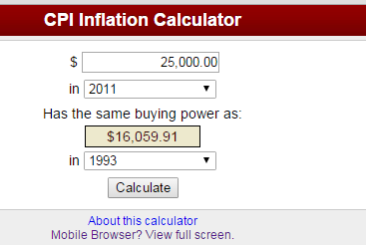 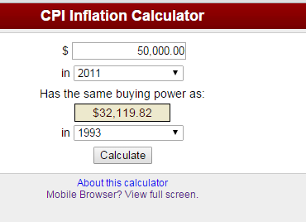

# reclassify income categories (low income: $0- $19,999; mid income: $20,000 - $34,999; high income: $35,000 or more; NA: refused)

# low <- (1,4); median <- (5,7); high <- 8:13

# lack household x, y coordinate, HTAZ

hh.metro <- hh %>%

mutate(inc.level=cut(INCOME,

breaks=c(1, 5, 8, 13.5),

labels=c("lowInc", "midInc", "highInc"), #allow alternative household grouping

include.lowest=T, right=F)

)

5. Household x/y coordinate

File: 1994 HHOUSEHOLD_xy.csv from Joe; import as epsg:

hhxy.df <- read.csv("data/portland_94/1994 HOUSEHOLD_xy.csv")

hhxy.df <- hhxy.df[which(!is.na(hhxy.df$hx)),]

spdf = SpatialPointsDataFrame(hhxy.df[, c('hx', 'hy')],

hhxy.df,

proj4string=CRS("+init=epsg:2913"))

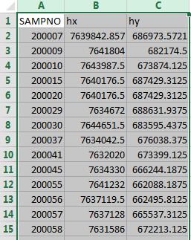

6. Straight line distance: not route distance

The x/y coordinate 1994_ax_ay.csv is from Joe, which is measured by feet:

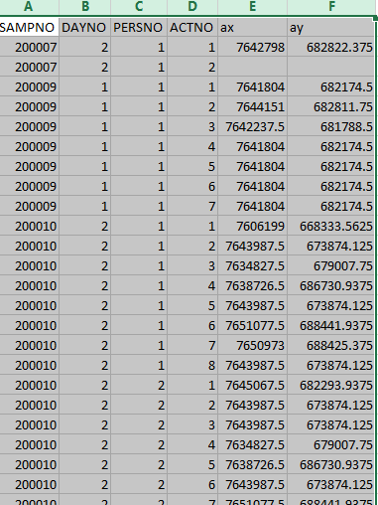

Thus, the distance is calculate as follows:

Function:

distance = function(x1,x2,y1,y2) {

xdiff = abs(x1-x2)

ydiff = abs(y1-y2)

d = sqrt(xdiff^2 + ydiff^2)

return(d) #distance feet

}

df$Distance = distance(df$LastXCORD, df$ThisXCORD, df$LastYCORD, df$ThisYCORD)

Because route file is not available for Portland_94, the distance is straight line distance instead of HHWGT. The route distance is calculated as follows:

routeDistance = tapply(route$Distance, paste(route$SAMPN, route$PERNO, route$OPLANO, route$DPLANO),

function(x) ifelse(length(x)==1,NA,sum(x[2:length(x)])) )

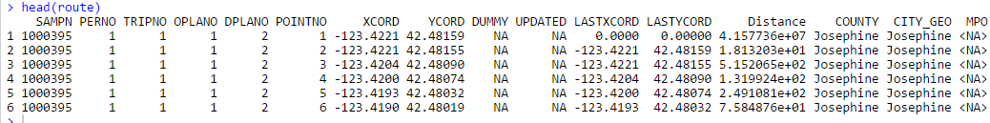

7. Lack HHWGT